**Name: Strickland, Timothy CMSC 335 Date: 2/7/2022**

**Project 2**

**Test Table**

|  |  |  |  |
| --- | --- | --- | --- |
| **Input** | **Expected Output** | **Actual Output** | **Pass?** |
| **Run Program** | **Menu Displayed** | **An eleven option menu is shown** | **Yes** |
| **10** | **GUI should launch** | **GUI launches to the front at the bottom left** | **Yes** |
| **Click Create Shape** | **New Window Pops Up prompting to enter a value** | **Window pop up, What is the radius?** | **Yes** |
| **200** | **Circle is drawn** | **Data of the circle shows up in left corner. Circle is created** | **Yes** |
| **Create Shape, -200** | **New Window pops up with error** | **Bad input, please input a number greater than 0.** | **Yes** |
| **Click OK** | **New Window pops up prompting for a value** | **Window pop up, What is the radius?** | **Yes** |
| **Hello** | **New Window pops up with error** | **Window pop up, Invalid shape: Circle** | **Yes** |
| **Click OK** | **Extra windows close** | **Extra Windows close** | **Yes** |
| **Cone, Create Shape, 200, 200** | **Should display image of cone** | **Cone is displayed. Data on the cone is on the left** | **Yes** |
| **Cube, Create Shape, 200** | **Should display image of cube** | **Cube is displayed. Data is displayed on left** | **Yes** |
| **Cylinder, Create Shape, 200, 200** | **Should display image of cylinder** | **Cylinder is displayed. Data is displayed on left** | **Yes** |
| **Rectangle, Create Shape, 200, 200** | **A new rectangle is created** | **Rectangle is drawn. Data is displayed on left** | **Yes** |
| **Sphere, Create Shape, 200** | **Should display image of sphere** | **Sphere is displayed. Data is displayed on left** | **Yes** |
| **Square, Create Shape, 200** | **A new Square is created** | **Square is drawn. Data is displayed on left** | **Yes** |
| **Torus, Create Shape, 200, 200** | **Should display image of Torus** | **Torus is displayed. Data is displayed on left** | **Yes** |
| **Triangle, Create Shape, 200, 200** | **Should display image of Triangle** | **Triangle is displayed. Data is displayed on left** | **Yes** |
| **Click on top right x** | **GUI closes** | **GUI goes away, program stops** | **Yes** |

**Screen shot 1**

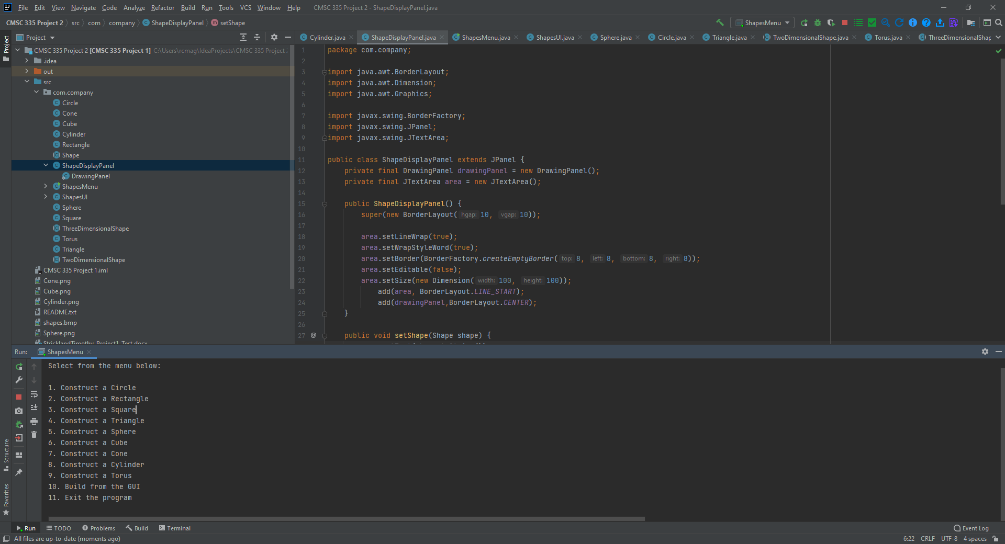

**Screen Shot 2**

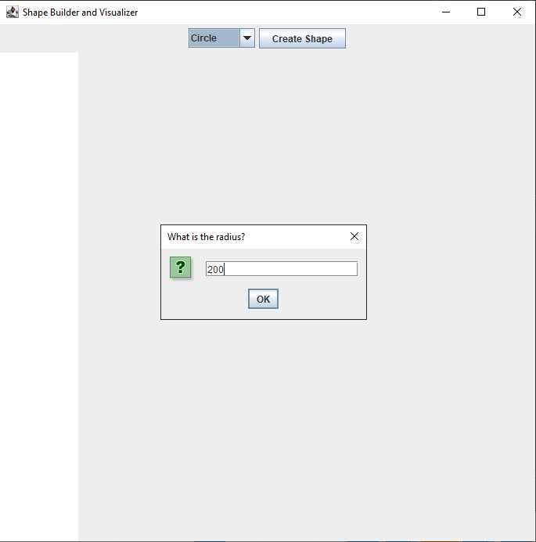

**Screen Shot 3**

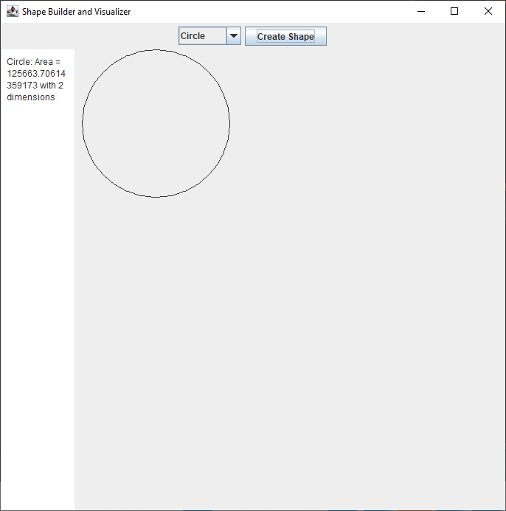

**Screen Shot 4**

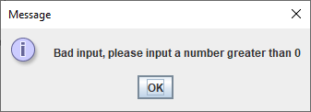

**Screen Shot 5**

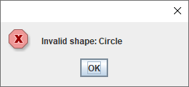

**Screen Shot 6**

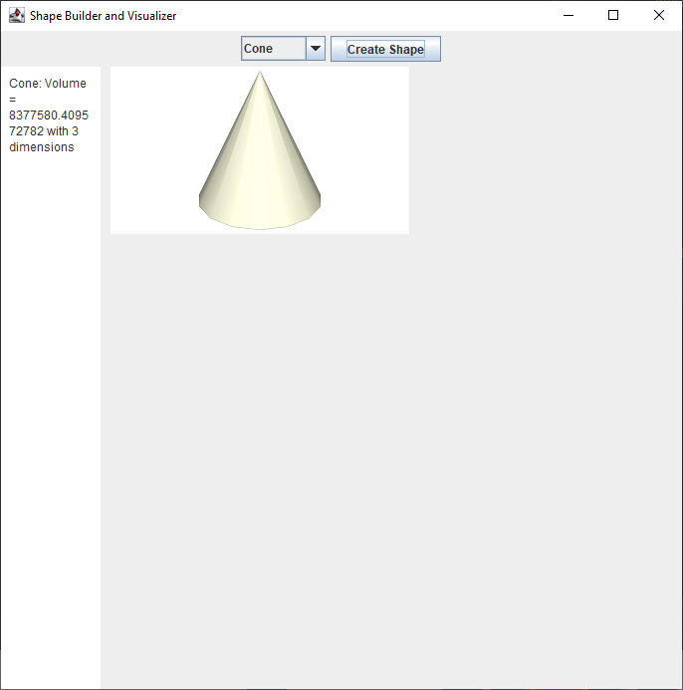

**Screen Shot 7**

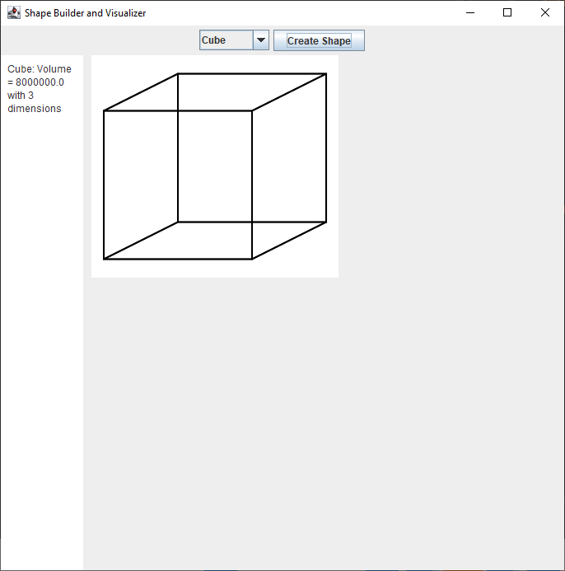

**Screen Shot 8**

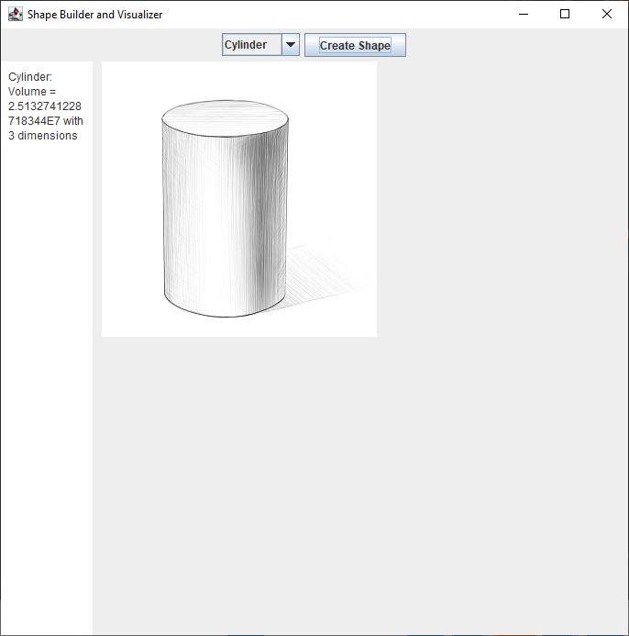

**Screen Shot 9**

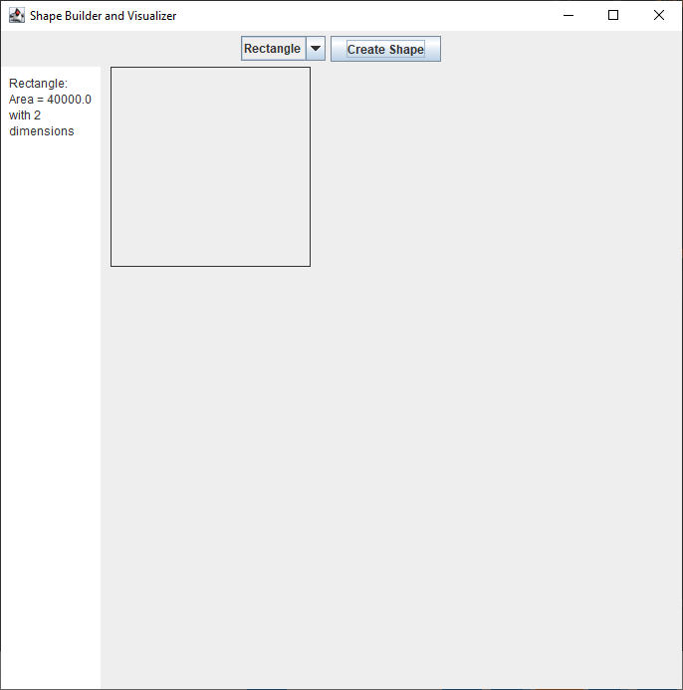

**Screen Shot 10**

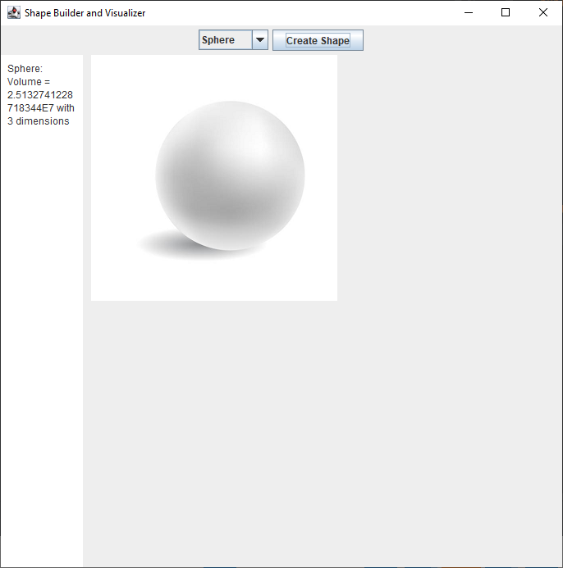

**Screen Shot 11**

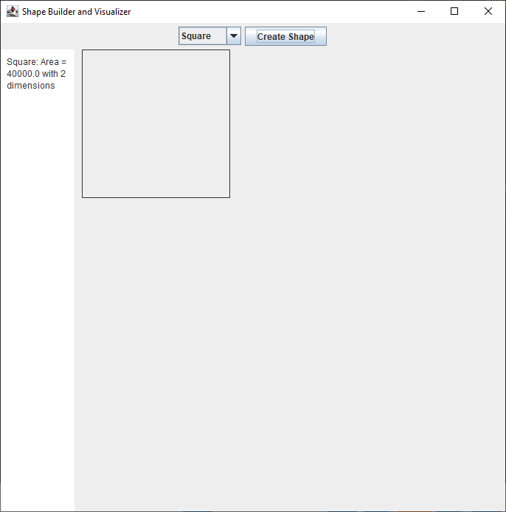

**Screen Shot 12**

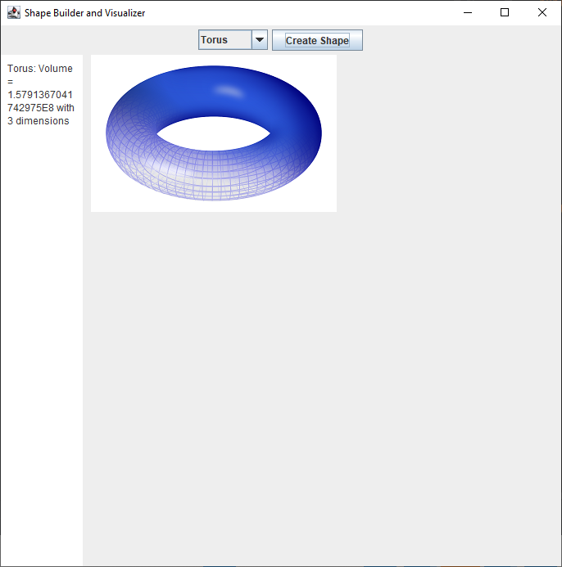

**Screen Shot 13**

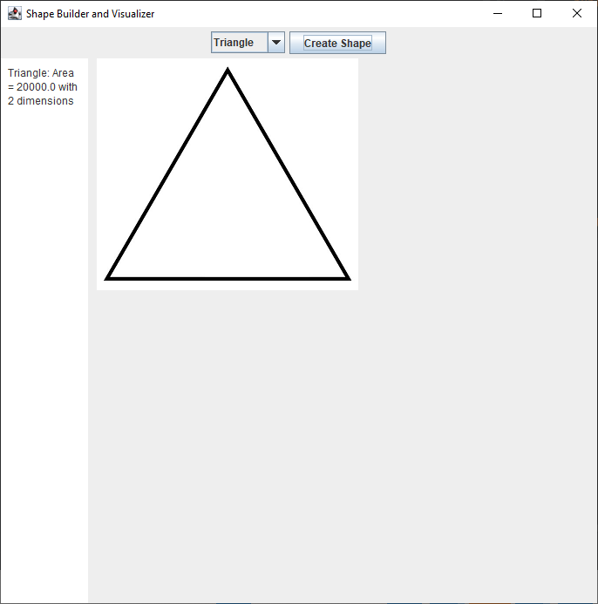

**Lessons Learned**

This project seemed to be easier than project 1. It helped to already have solid code to build upon. The professor’s examples really helped me grasp the concepts of object orientation. My goal now when I write code is to get it working first and then when I try to organize and clean it, focus on how I can make the code re-usable across the board, don’t repeat code, and abstract things as much as possible. Also I have learned that it is best to give access to smallest area possible, rather than letting all parts of the code access others.